

Socket Programming Assignment Report

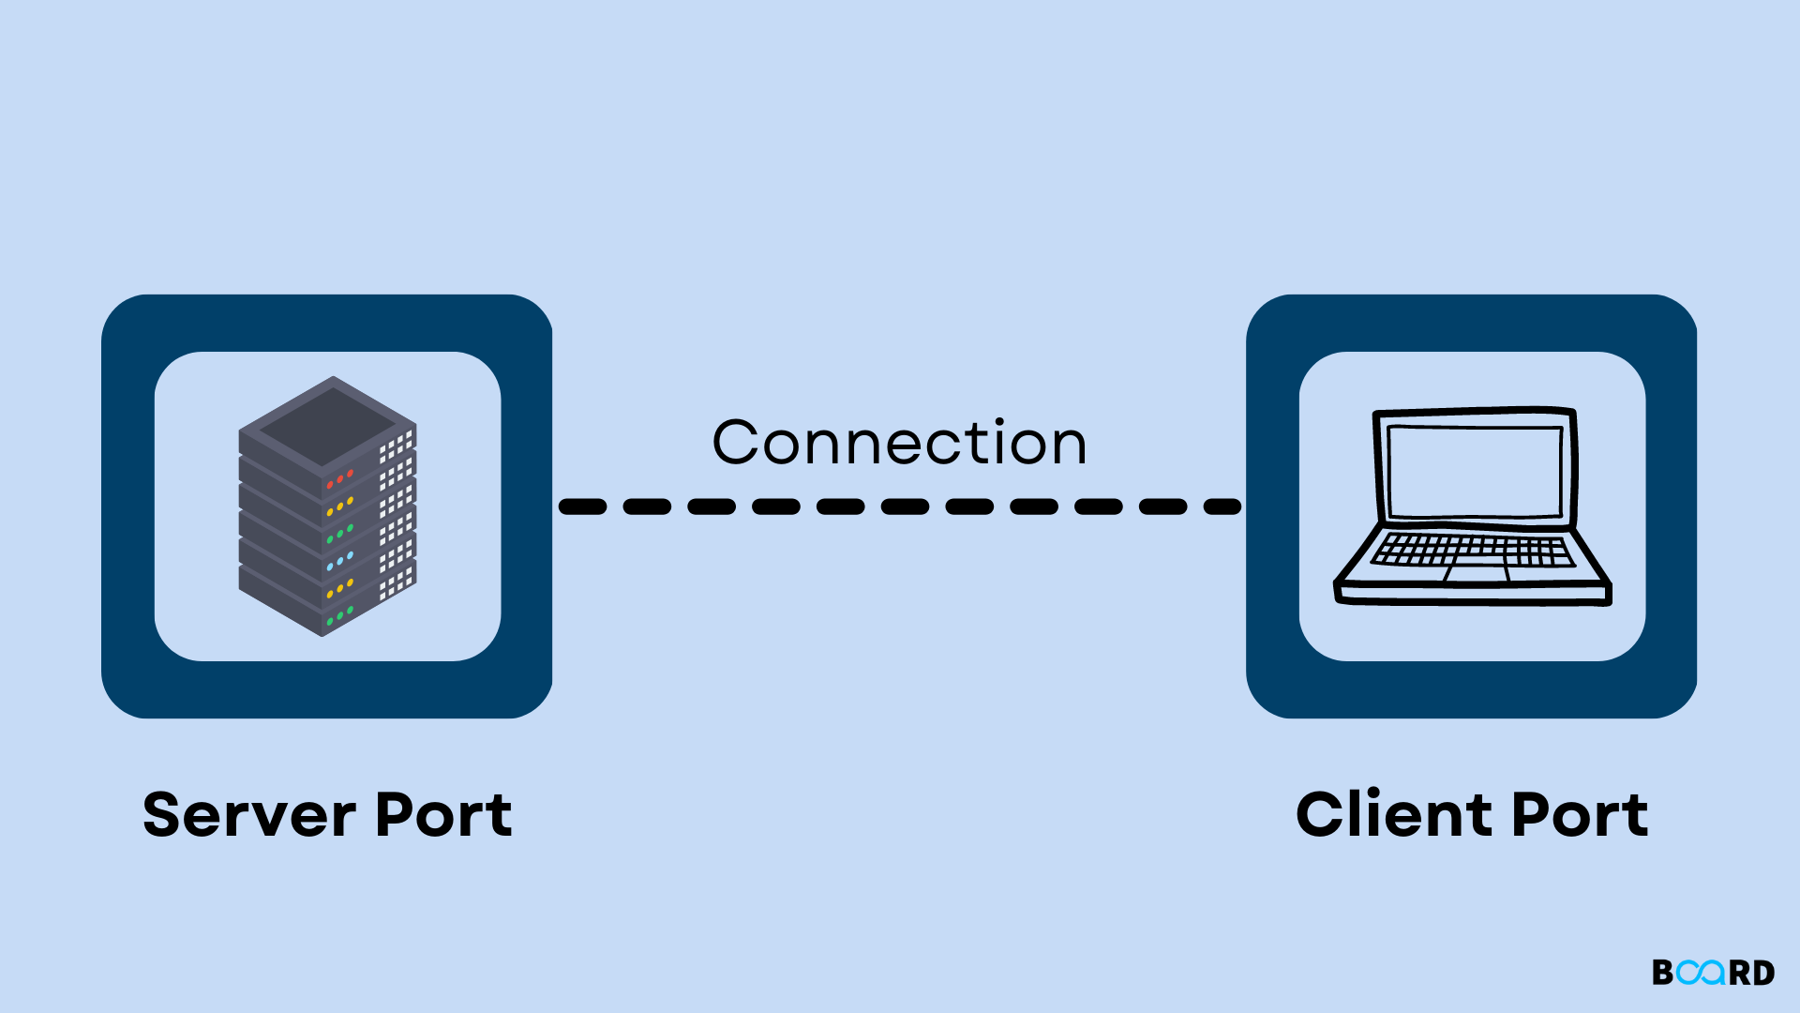

Supervisor: Mr.Akash Tharuka

Chatting system using TCP/UDP Sockets
Course: CSCI 21023 - Data Communication and Networks (2023/2024)
Date: 19/11/2025
B.Sc. (Honours) in Computer Science
Programming Language: Python
GitHub repository URL : https://github.com/KSDeshan/Socket_Programming_Project.git

- Group Members and Roles

Members | What They Did
CS/2022/002 | - Set up Azure VM
CS/2022/017 | - Make the chat window (GUI)  - Test everything works
CS/2022/037 | - Write client.py
CS/2022/052 | - Write server.py

2. System Setup and Configuration
Client 1 ←→ Azure Server ←→ Client 2
(20.205.17.204:5000)

Component | Specification
Cloud Server | Azure VM, Windows, Standard D2s v3 (2 vcpus, 8 GiB memory)
Public IP | 20.205.17.204 (Static), Port: 5000 (TCP)
Host 1 | Windows 11, Role: Client 1
Host 2 | Windows 11, Role: Client 2
Network Security | Azure NSG: Allow TCP 5000 inbound from Any
Protocol | TCP ,Header: 64 bytes, UTF-8 encoding

Client to client pass message
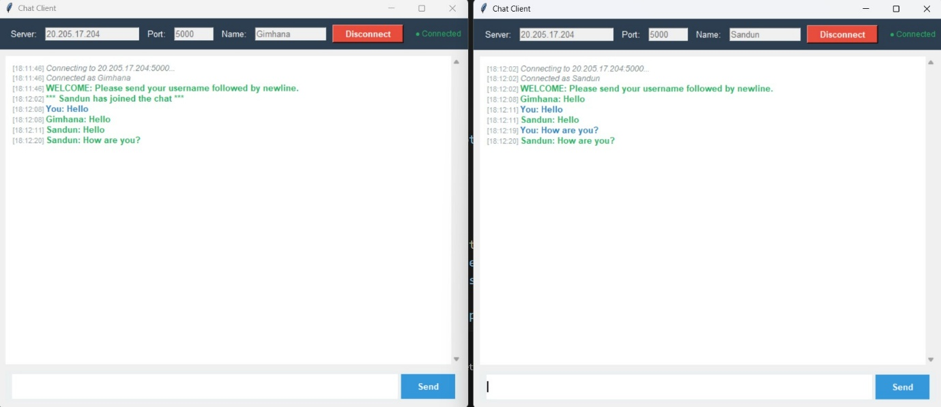
Passing message
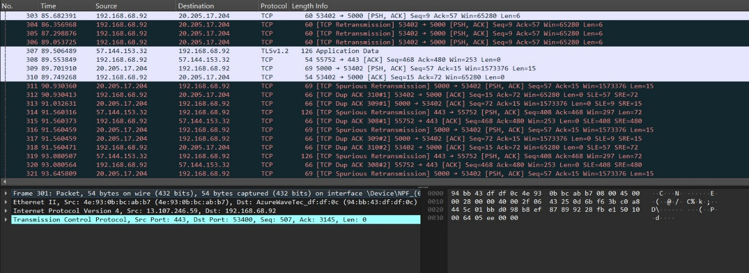

User Connecting to Server
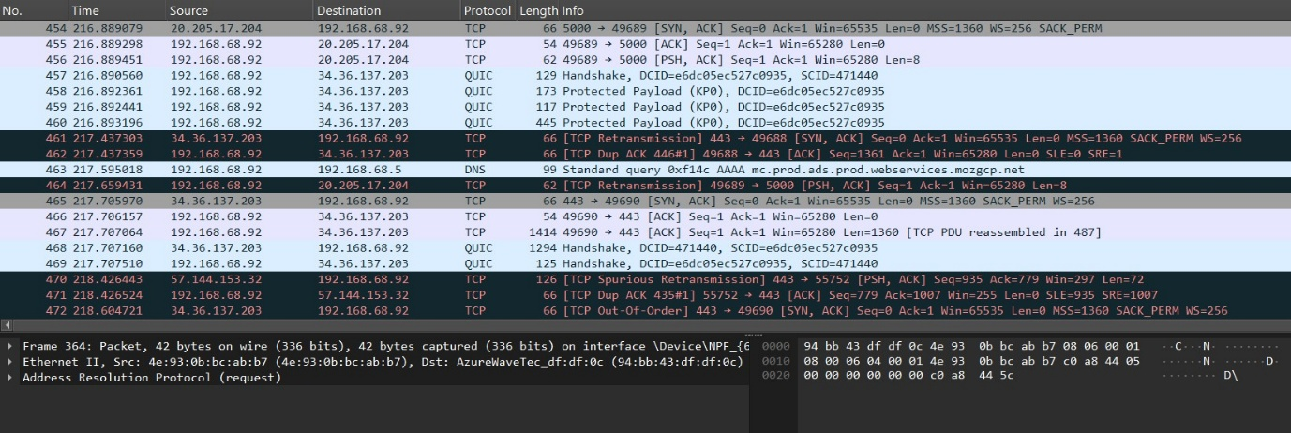

Disconnected From Server 